To sign into Quaver Music through our District portal:

- Open an internet browser like Chrome or Firefox.
- If you are on the Laurel Music Website, click on a button that says

IT IS VERY IMPORTANT THAT YOU USE THIS ADDRESS AND NOT THE NORMAL QUAVER PAGE THAT YOU WOULD FIND BY GOOGLING.

Alternatively:

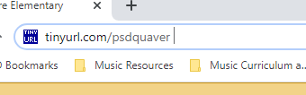

- You should see a screen that looks something like this:

- Now login using your PSD email (######@psdschools.org) and password (####+initials twice). Click “Sign In.” This is the login for PSD email for each student.
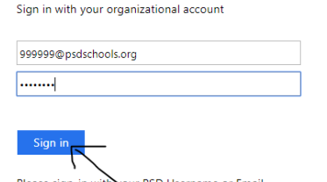

- You will probably see this screen. Click No.
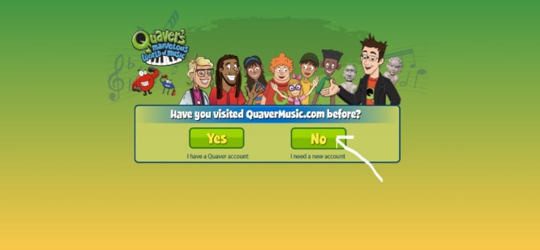
- You should now be at the Quaver Student Dashboard page. This page (below) is what you will see in the future when you sign in through tinyurl.com/psdquaver. It is recommended that you bookmark this page.

Click “Quaver Street” to go to this screen:
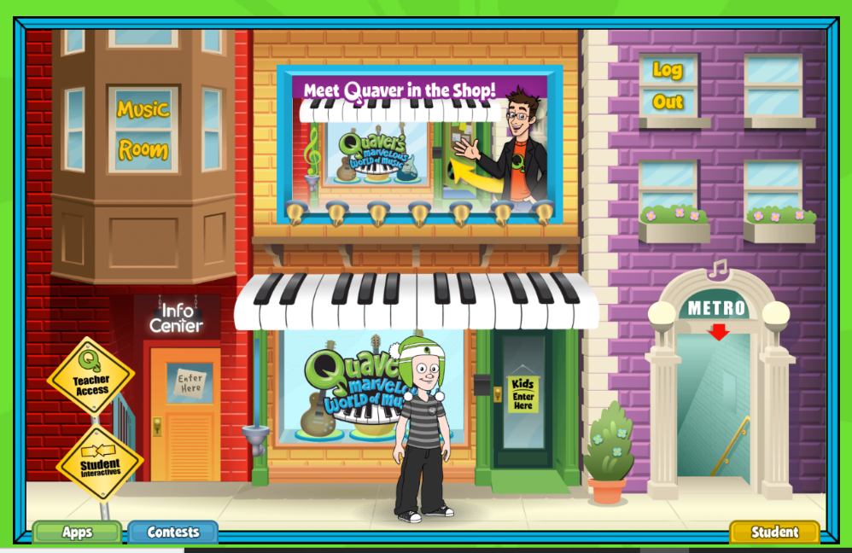

On Quaver Street, you can explore the “Metro” and “Student Interactives”. You can look at all options by clicking the “Apps” tab at the bottom left. You can return to the “Student Dashboard” by clicking the yellow “Student” tab at the bottom right.

- Students can customize their avatar by clicking on the “My Avatar” tab on the Student Dashboard.
